President

### Bangert Elementary

North Carolina

Newsletter #3

November 8, 2016



First Grade News!

**Tuesday, November 8**: Election Day; School **IS** in session!

**Thursday, November 10**: Early Release Day; Students dismiss at 12 noon

**Friday, November 11**: No school for students and staff in recognition of Veteran’s Day.

**Tuesday, November 15**: Reading Fun Night. Come for a FREE hot dog dinner (please RSVP) and do fun activities around the school from 5:30-7:00 pm.

**Wednesday,** **November 23:** Early Release Day to make up for an inclement weather day; Students and staff dismiss at 12 noon

**Thursday, November 24-Friday, November 25**: No school to celebrate the Thanksgiving holiday

# Please Remember to…

* Send in a sweater/sweatshirt for students to wear in colder areas because temperatures vary around the school.

In reading we are concluding our unit on building good habits as a reader. We will practice thinking before we read, solving words as we read, and rereading or thinking about the book after reading. We are practicing this work with a partner this week. We will then switch our focus to nonfiction texts. Students will identify and use nonfiction print conventions that authors use to tach the reader such as headings, captions photographs, diagrams and labels.

In math students have learned how to identify equivalent equations and explain their thinking in writing. We have also learned about fact families using the commutative property. Next, our students will learn several addition strategies and skills. They will add doubles and doubles plus one, learn ways to add 3addends together, as well as focus on solving word problems.

In November, we will study the meaning of Veteran’s Day and symbols of America. In addition, we will learn about a variety of Native American tribes and how they used natural resources around them to survive. Then we will explore the history surrounding the holiday of Thanksgiving.

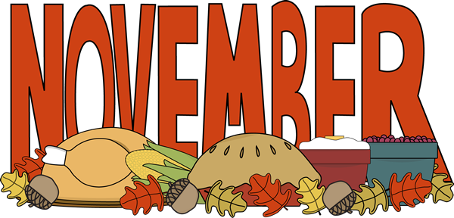

# What We Are Learning

Ongoing Units, Dates & Reminders

# Dates to Remember:

.